**Schedule of the property**

Dist- Dhaka. PS & Sub Registry office-Savar with in Dhaka Collectorate Touzi- 106, Mouza- Kulashur, Khatian No. S.A-09, Mutation -9/2, Plot No.C.S & S.A-40, land measuring 13 decimal.

Dist- Dhaka. PS & Sub Registry office-Savar with in Dhaka Collectorate Touzi-106,,Mouza-Kulashur, Khatian No.C.S-07, S.A-08,R.S-22, Mutation -8/Part, Plot No. C.S & S.A-41, R.S-21, land measuring 11.50 decimal along with all construction & structures.

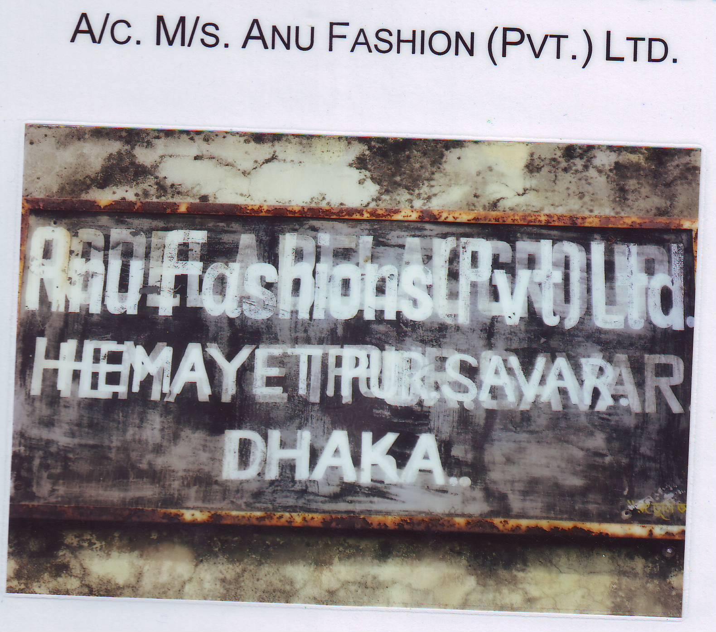

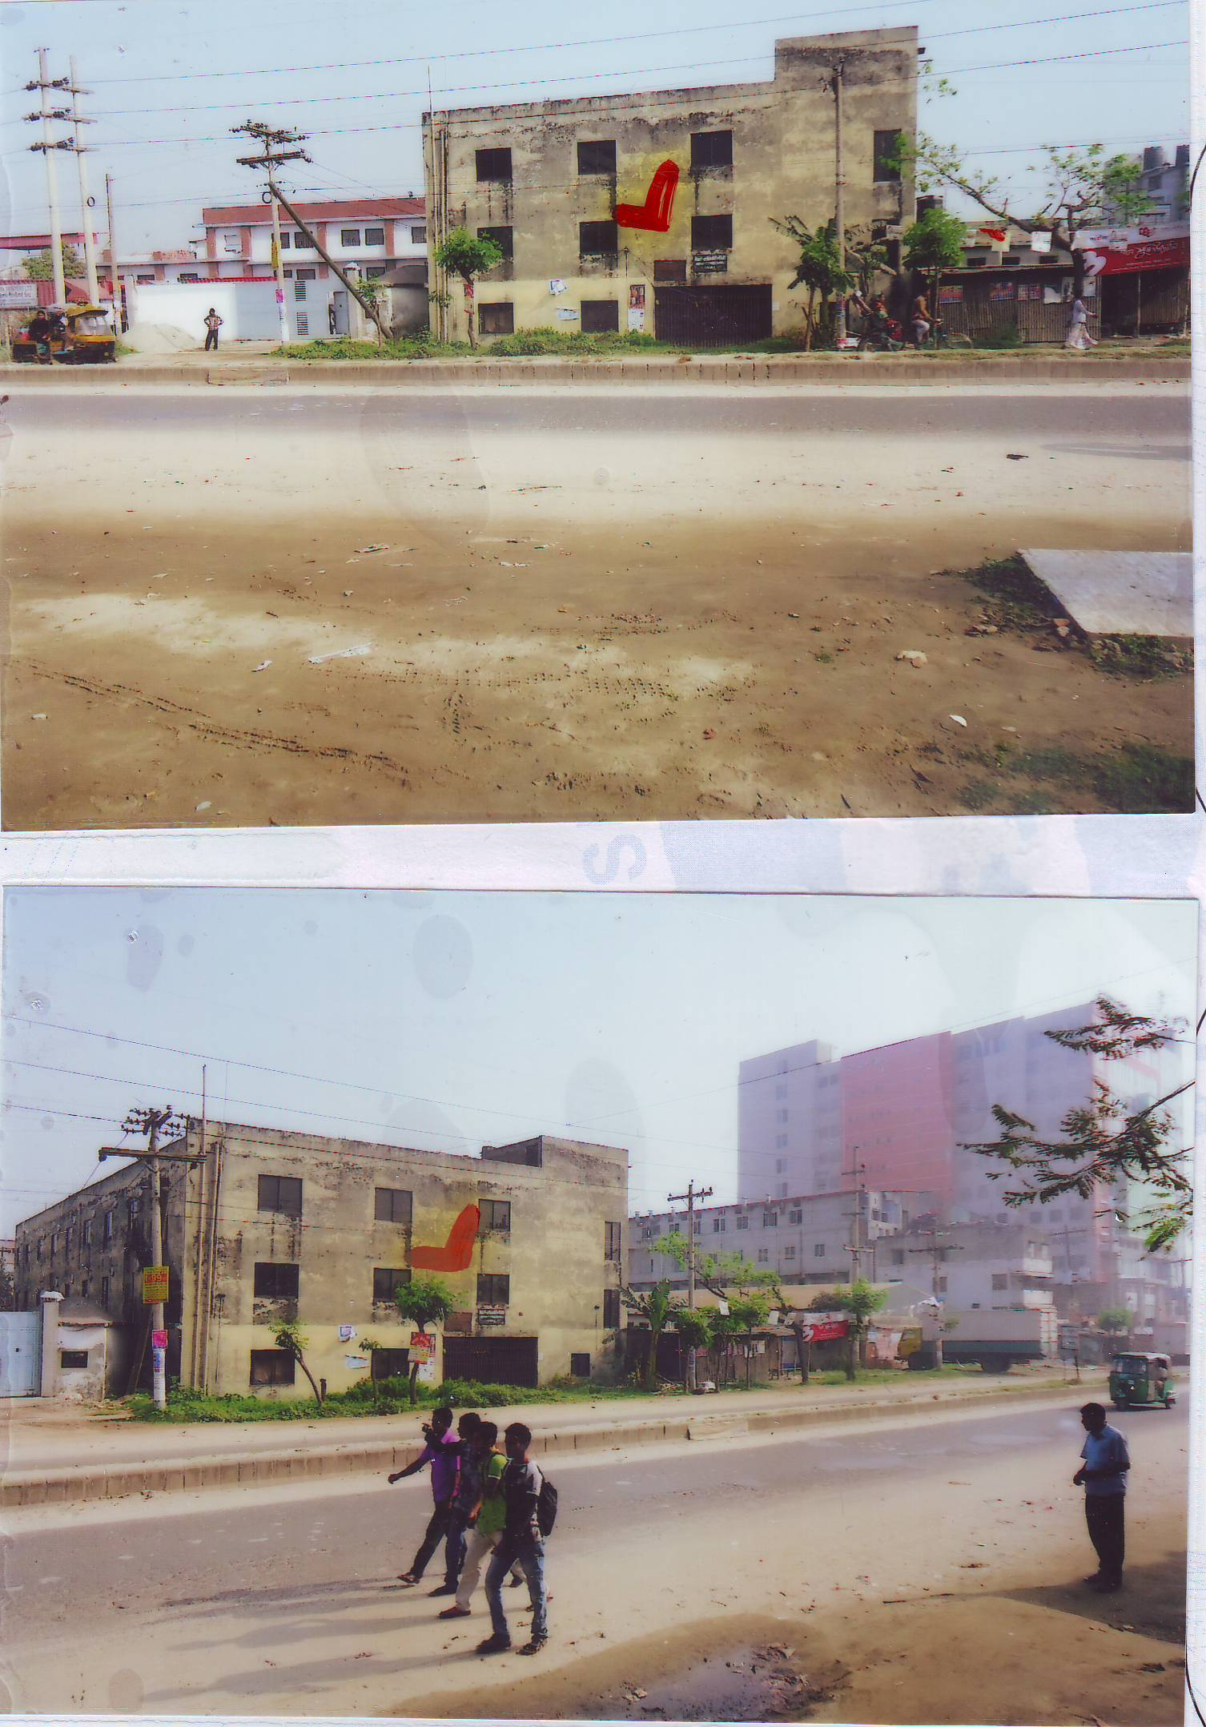

**Total outstandingTK. 100.39 million as on 20.10.2014**