A/C Name BURO Attached with P.O. Br.

**Schedule of the Property (A)**

District : Jamalpur, Thana / P.s. : Jamalpur Sadar, Sub Registry Office : Jamalpur, Mouza : Singhajani, J.L. No. : 275, Khatian No. : 397, Dag No. : 1051, 1052.

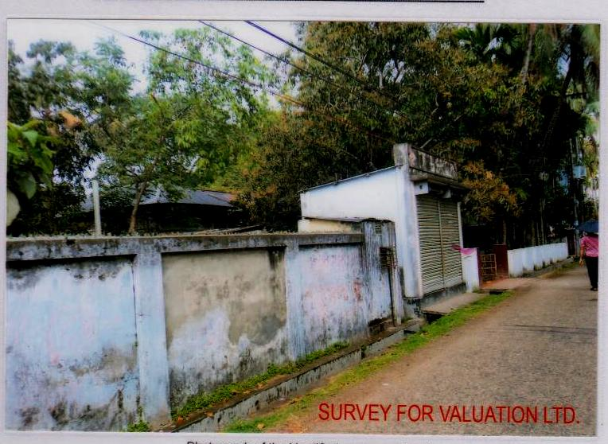

**Schedule of the Property (B)**

**Dag No. : 1424, Mouza : Singhajani, Location : Banpara, P.O. : Jamalpur, P.S. : Jamalpur, Dist. : Jamalpur**

