**Schedule of the property**

Dist. Narsindi P.S & Sub-registry office-Monohardhi, JL No- 119 Mouza Haradiah khatian No. 50 & 25/2, dag No. 318,755,645 and 754 area of land 89 decimal.

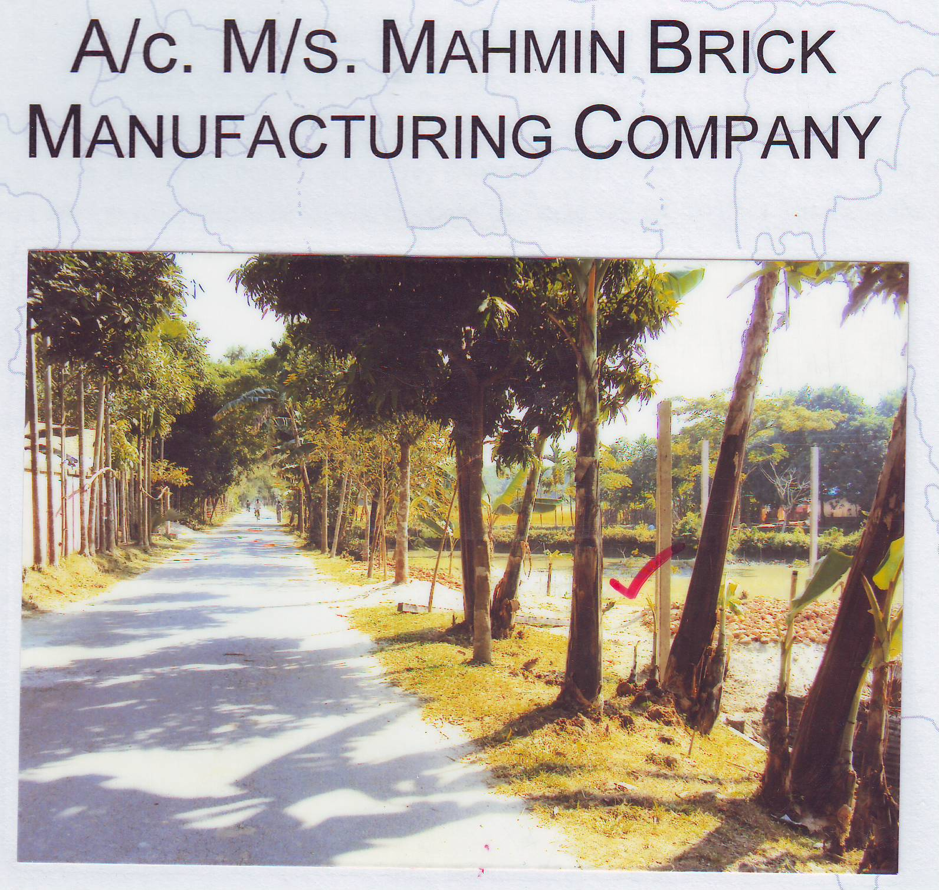

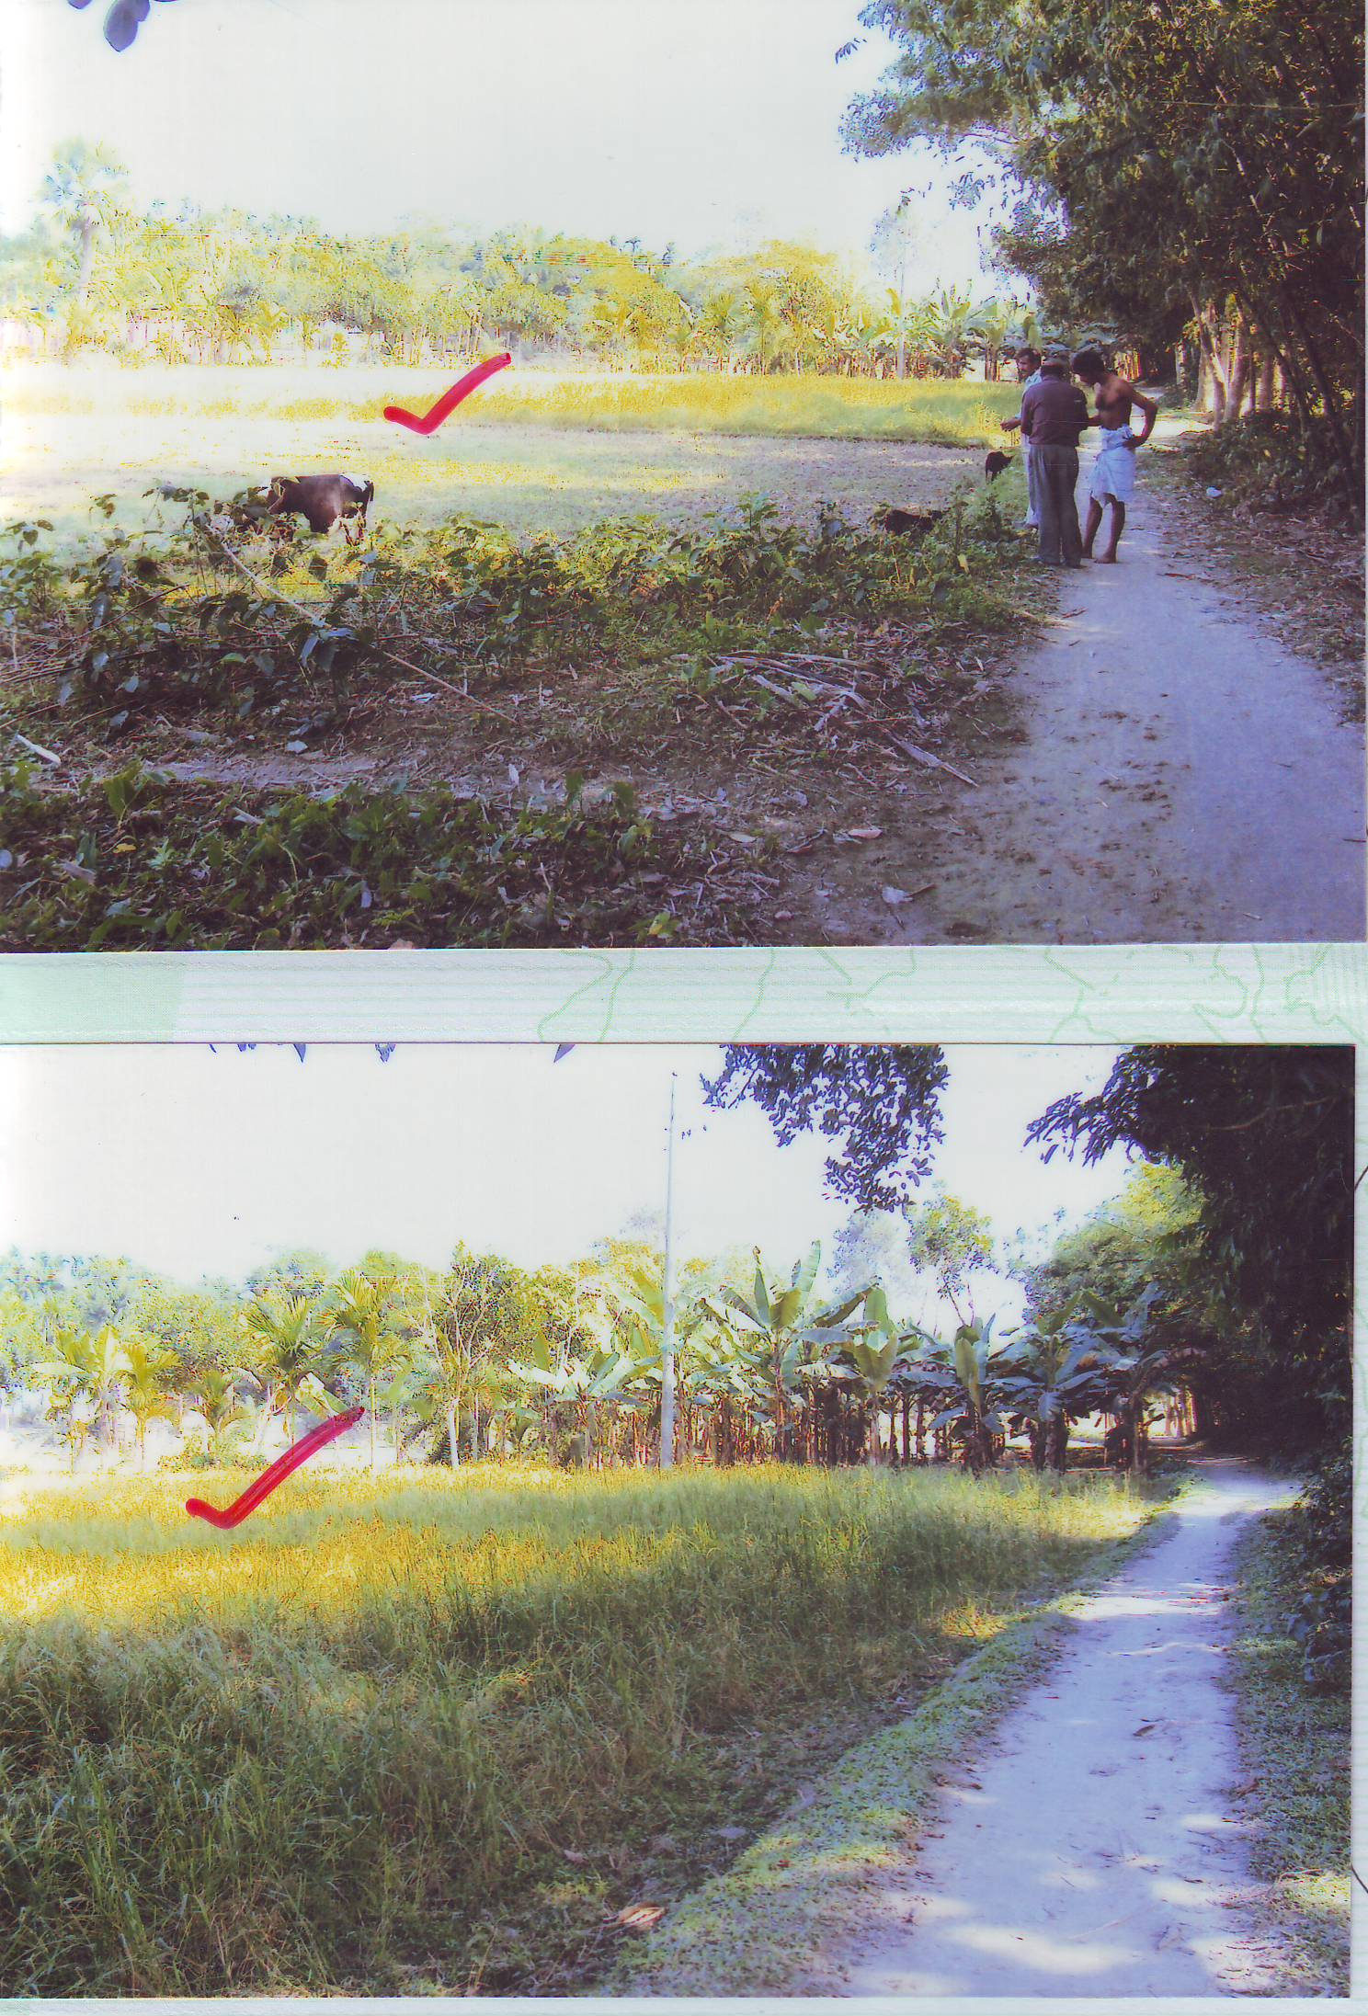

Total outstanding Tk.2.28 million(including uncharged profit) till 31.12.2013