**Schedule of the property**

01 (One) bigha, 15 (Fifteen) Kathas land with boundary wall. Word No. 3, sheet No. 67, CS Khatian Nos.5021 & 5032, Dag No. 83/91, 4158,4159,4160,4161& 4162. PS Sutrapur, Shamibag, Dhaka, Holding No. 57 Dist: Dhaka.

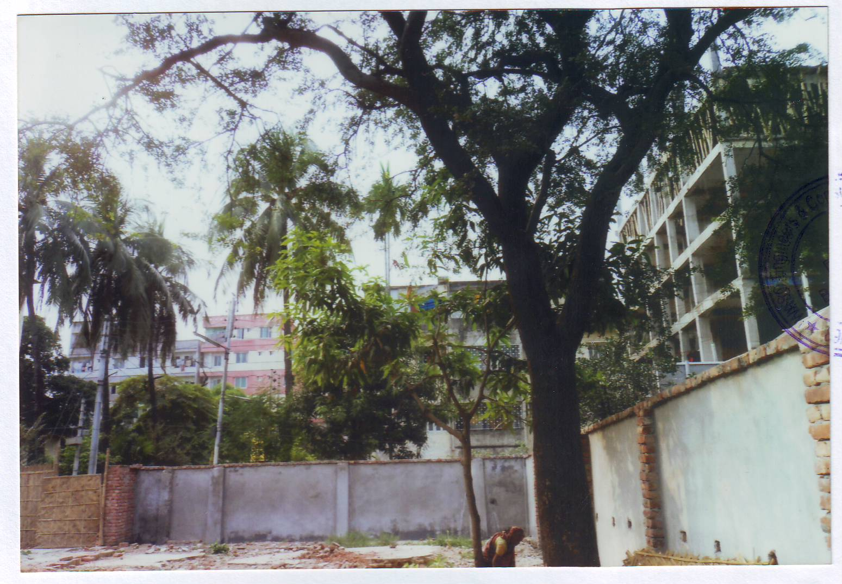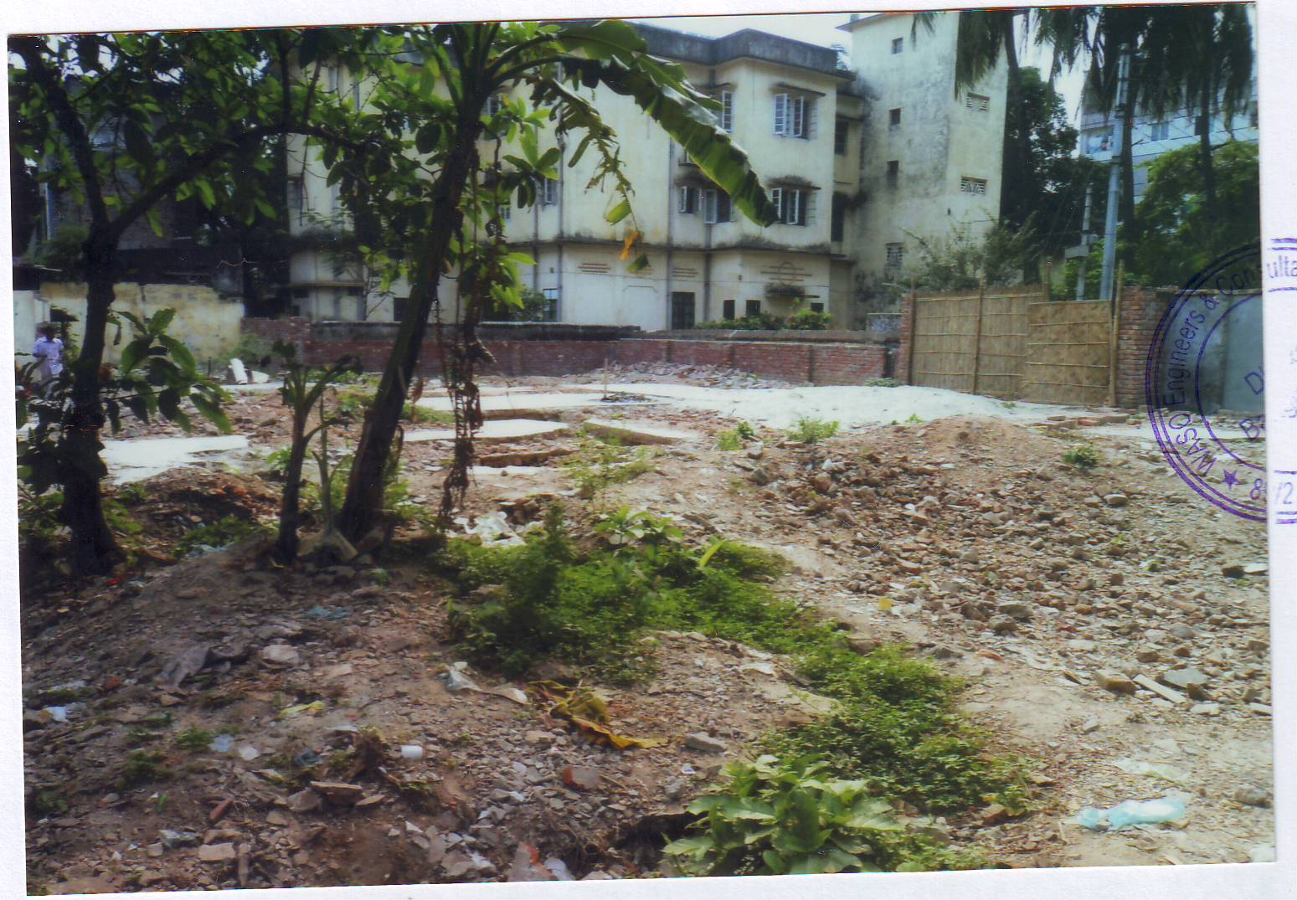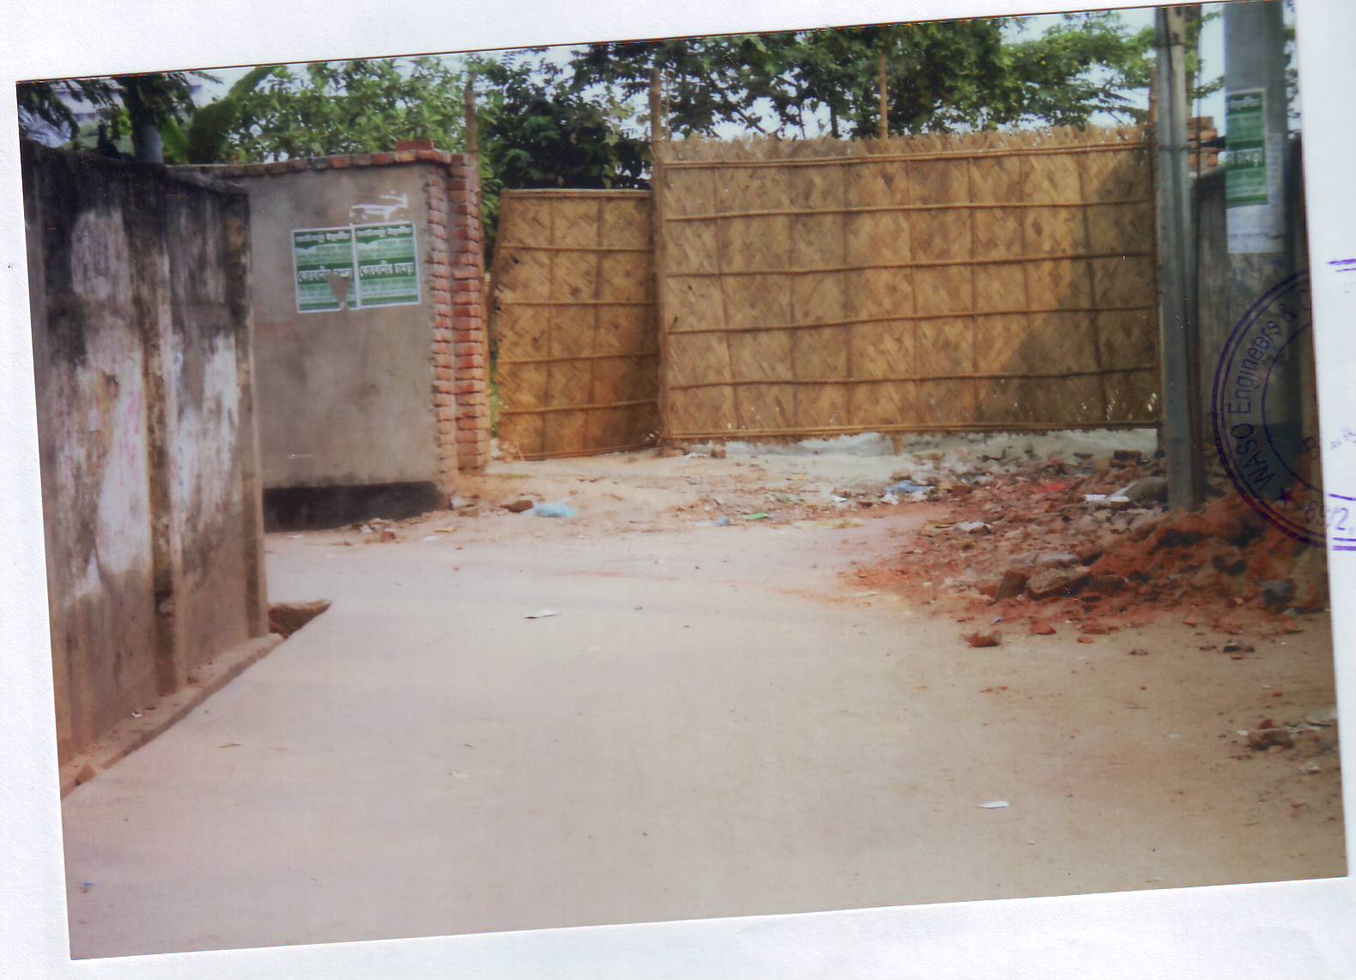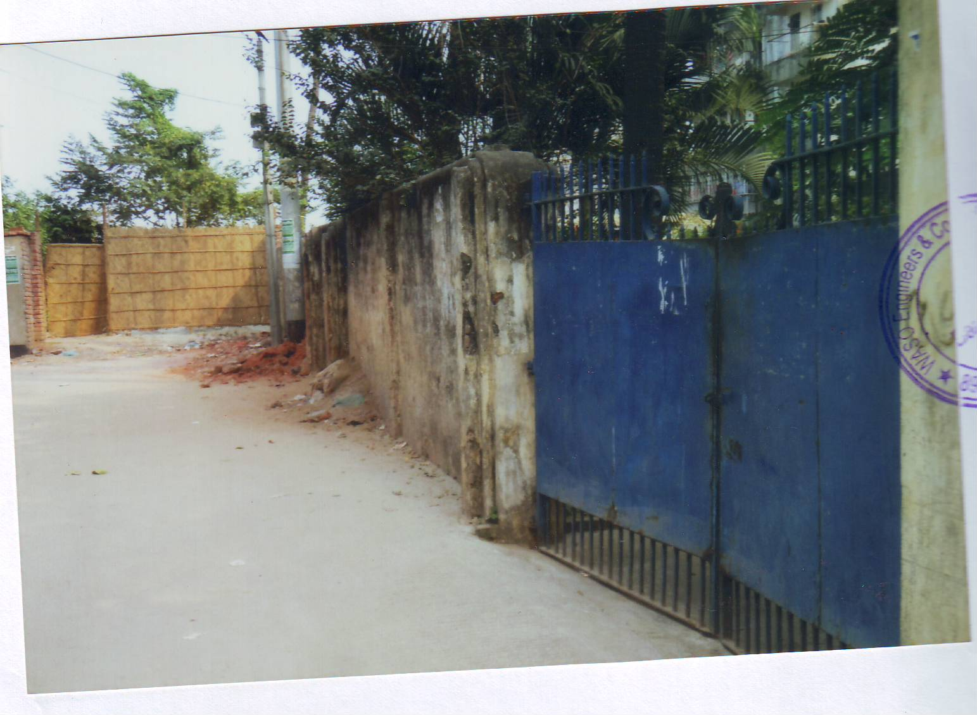

Total outstandingTk.13.55 million(including uncharged profit) till 31.12.2013